Table 1. A priori regions of interest used in the NEURO ALC study.

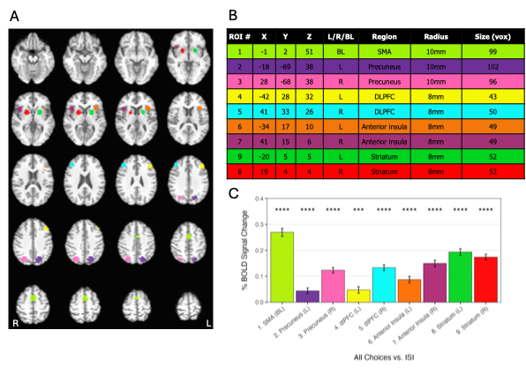
Note. Slices are displayed in radiological convention (L=R) and range from Z = -14 to +62 with 4 mm spacing. Coordinates are reported as cluster centers of mass in Talairach space using the RAS convention. Reported cluster size is based on 3.5 mm isotropic voxels.

